NAME:K.SAI susanth
PIN NO:18481A04A5
IOT ASSIGNMENT-2

AUTOMATIC GARAGE DOOR OPENING SYSTEM

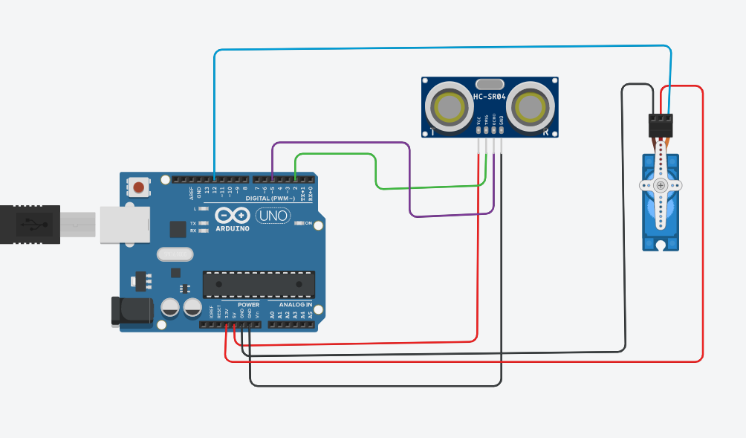

#include<Servo.h>
Servo myservo;
int trigpin=2;
int echopin=5;
void setup()
{
pinMode(trigpin,OUTPUT);
pinMode(echopin,INPUT);
myservo.attach(12);
Serial.begin(9600);
}
void loop()
{
digitalWrite(trigpin,HIGH);
delay(1000);
digitalWrite(trigpin,LOW);
float duration=pulseIn(echopin,HIGH);
float distance=(duration*0.034)/2;
Serial.println("the distance is");
Serial.println(distance);
if(distance<=100)
{
myservo.write(90);
Serial.println("servo is at a angle 90");
delay(1000);
}
else
{
myservo.write(0);
Serial.println("servo is at a angle 0");
delay(1000);
}
}

